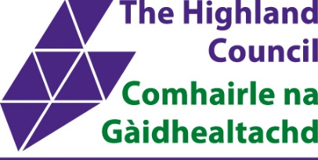
Hybrid/Mobile Working
Team Agreement

A template agreement has been provided below, with headings and prompts that relate back to the Developing a Team Agreement Guidance in the Flexible Working Arrangements Guidance for Managers.

Please note, the headings provided below are suggestions and managers can adjust as required to meet the team’s needs. Managers may also use an alternative format to record the team agreement.

Service:
Manager:
Team Members:

Section | Details
Aspirations for our team | What are our objectives? How do we want to achieve our objectives? How do we support each other with personal development and how do we ensure learning opportunities are provided equitably?
Where we work | From which locations can/must we work from? When will we work from these locations? Which tasks are better suited to in-person vs. remote? How many desks in the office workspace will the team require on any given day?
When we work | What are all the team members’ work patterns? How can we make contact with each other during working hours? How will we know when each other are available i.e. Outlook calendar, Teams etc?
How we communicate as a team | How frequently will we meet as a full team and individually? Where and how will we come together, i.e. meeting room, collaborate workspace, online?
Equipment and Workspace | What additional workspace is required, i.e. hot desks, meeting rooms, collaborate or confidential spaces? What equipment is needed to support hybrid working?
Participants | Detail all team members who are included in this agreement here.
Ongoing review | How often will we review these arrangements and this Team Agreement?
Anything else | Are there any considerations for our next review, i.e. reviewing a trial period? Were suggestions made that could be put in place by the next review date?

Have all team members agreed to the arrangements?
Date of agreement:
Date of implementation:
Review date:

