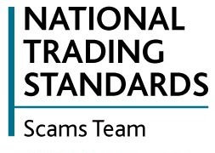
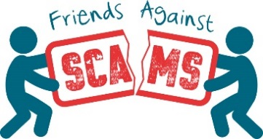
Coronavirus Social Media Pack
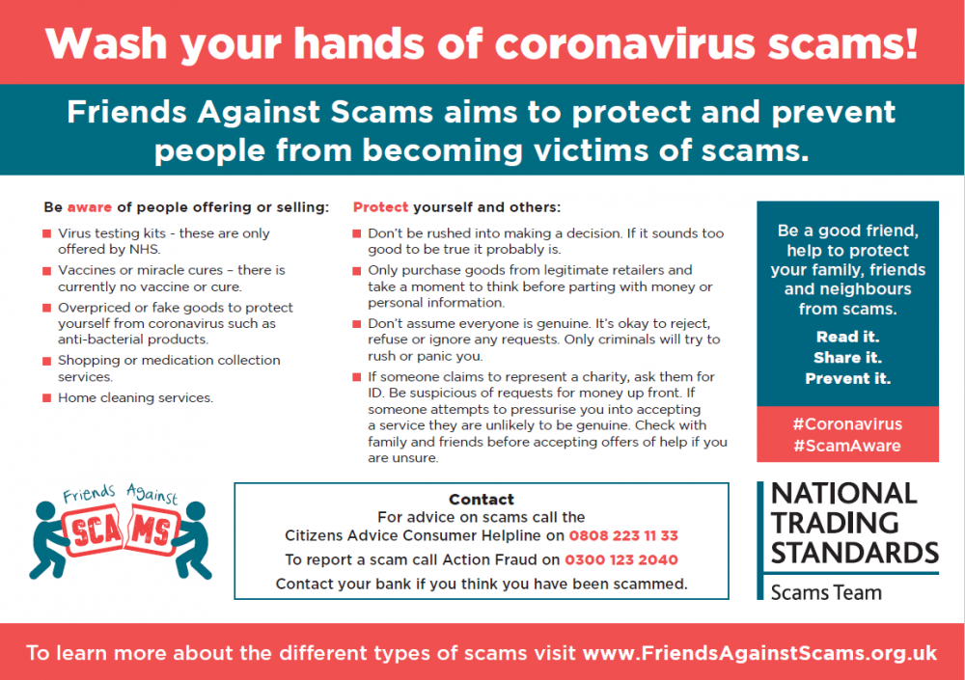
The team have produced a social media pack alongside the press release (https://www.friendsagainstscams.org.uk/article/505/beware_of_covid_19_scams) and letter template. Please share these posts to draw attention to the infographic below that has been designed on how to protect yourself and others from coronavirus scams. The Friends Against Scams training has been updated to include further information on the types of coronavirus scams the team have seen and actions to take to protect yourself and others.

Supporting infographic: | Content: | Platform:
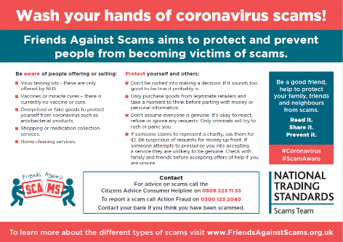 | Wash your hands of coronavirus scams and share this postcard with friends and family, protect yourself and others #Coronavirus #ScamAware |   
 | Share this infographic with your friends and family to make sure we are all #ScamAware about #Coronavirus
 | Read it. Share it. Prevent it. #Coronavirus #ScamAware
 | Be aware of people offering or selling items to test for/cure coronavirus. These are not currently available to purchase. #ScamAware #Coronavirus
 | Be aware of people offering shopping or medication collection services. Don’t assume everyone is genuine. It’s okay to reject, refuse or ignore any requests. Only criminals will try to rush or panic you. #ScamAware #Coronavirus
 | If someone claims to represent a charity, ask them for ID. Be suspicious of requests for money up front. If someone attempts to pressurise you into accepting a service, they are unlikely to be genuine. #ScamAware #Coronavirus
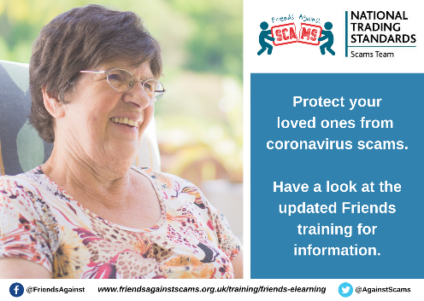 | Wash your hands of coronavirus scams! The Friends Against Scams training has been updated to include information on coronavirus scams – complete it here: https://www.friendsagainstscams.org.uk/training/friends-elearning #Coronavirus #ScamAware
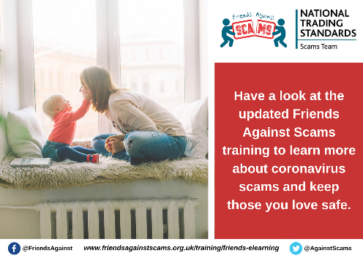 | The Friends Against Scams training has been updated to include information around #Coronavirus scams. Complete the training and send it to your friends and family to make sure everyone is #ScamAware https://www.friendsagainstscams.org.uk/training/friends-elearning

