Suicide Prevention Week 2018
Social Media Briefing
Suicide Prevention Week (SPW) takes place from Mon 10 to Sun 16 September 2018.
This year’s theme for Suicide Prevention Week is ‘Working Together to Prevent Suicide’.
NHS Health Scotland is using SPW to raise awareness of the problem of suicide, highlight resources (evidence informed guidance, research reports and training opportunities). We will also be supporting key partners’ public awareness campaigns.
Throughout the week there will be tweets from the NHS Health Scotland Public Mental Health twitter account @NHSHS_MH.
Tweets will also come from the NHS Health Scotland corporate account and the following team accounts: Healthy Working Lives; Children Young People & Families; Place Standard; Knowledge Services and Learning and Improvement.
Re-tweeting by partners is welcomed and encouraged to ensure we are reaching our maximum audience across Scotland.
We will be using the hashtag #WSPD (World Suicide Prevention Day) in order to be part of a global discussion on suicide prevention.

NHS Health Scotland twitter accounts include:
NHS Health Scotland Corporate Account @NHS_HS
NHS HS Health Working Lives @NHS_HWL
NHS HS Children Young People and Families @NHS_CYPF
NHS HS Place Standard @Placestandard
NHS HS Learning and Improvement Team @NHS_HS_LANDI
NHS HS Knowledge Services @NHS_KS

Partner twitter accounts (where available) include:
NHS Territorial and Special Boards @NHS_Scot; @NHS_Education; @JubileeHospital; @NHS24; @NHSNSS; @NHSaaa; @NHSBorders; @DGNHS; @nhsfife; @NHSForthValley; @NHSGrampian; @NHSGGC; @NHSHighland; @NHSLanarkshire; @NHS_Lothian; @NHSOrkney; @NHS_Shetland; @NHSTayside; @NHSWI
Scottish Government @scotgov
CoSLA and Local Authorities @COSLA; @AberdeenCC; @Aberdeenshire; @AngusCouncil; @argyllandbute; @ClacksCouncil; @cne_siar; @dgcouncil; @DundeeCouncil; @EastAyrshire; @EDCouncil; @ELCouncil; @EastRenCouncil; @Edinburgh_CC; @falkirkcouncil; @FifeCouncil; @GlasgowCC; @HighlandCouncil; @inverclyde; @midgov; @TheMorayCouncil; @North_Ayrshire; @nlancouncil; @OrkneyCouncil; @PerthandKinross; @RenCouncilNews; @scotborders; @ShetIslandsCll; @southayrshire; @SouthLanCouncil; @StirlingCouncil; @WDCouncil; @LoveWestLothian
Health & Social Care Partnerships @abhscp; @AngusHSCP; @EAHSCP; @EastDunHSCP; @EdinburghHSCP; @FifeHSCP; @GCHSCP; @HSCAberdeen; @HSCMoray; @HSCPshire; @InverclydeHSCP; @NAHSCP; @RenHSCP
Police Scotland @policescotland
Samaritans Scotland @Sams_Scotland
The Scottish Association for Mental Health @SAMHtweets
See Me @Seemescotland
The Health and Social Care Academy @HandSCAcademy ‏
The Mental Health Foundation @MHFScot
The Mental Welfare Commission for Scotland @MentalWelfare

Scheduled Tweets
Matrix Table:
Date of tweet | Tweets/graphics | @NHSHS_HS | @NHSHS_MH | @NHS_CYPF | @NHS_HWL | @NHS_HS_LANDI | @NHS_KS | @Placestandard
10.09 | People across Scotland and beyond are using the hashtag #WSPD this week to help draw attention to Suicide Prevention Week. This is your chance to get involved and raise awareness around suicide. #WorkingTogetherToPreventSuicide #WSPD | retweet | LEAD |  | retweet
10.09 | In Scotland 3 in 4 suicides are male. We need to break the stigma and make sure men of any age know there is support available. #WSPD  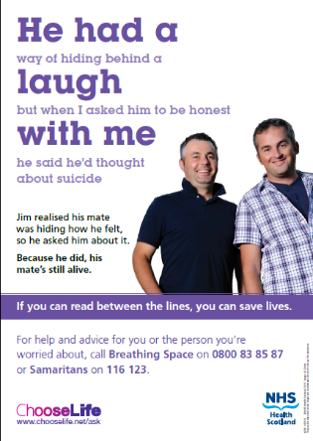 | retweet | LEAD |  | retweet
10.09 | It's Scotland’s Suicide Prevention Week. Good progress has been made in bringing down the rates of suicide in Scotland. However working together we can do more. Speak to one of Scotland’s Choose Life Coordinators about preventing suicide in your community. https://goo.gl/kJ4Rmy |  | LEAD |  | retweet
11.09 | Is it acceptable that a low social position increases suicide risk x 2.5 times? Find out more on our website about suicide and #HealthInequalities: https://goo.gl/YL2jZg #WSPD  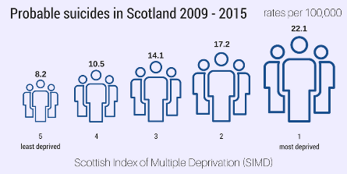 | LEAD | retweet |  | retweet
11.09 | Scotland’s Suicide Prevention Action Plan: Every Life Matters has been influenced by the partnership between @Sams_Scotland @ALLIANCEScot @NHSHS and those directly impacted by suicide. Read the Action Plan & find out more on suicide prevention work in Scotland: https://goo.gl/uwEXWP #WSPD | retweet | LEAD
11.09 | We must all work together to realise the target of reducing suicides in Scotland by another 20% by 2022. Suicide is preventable and by using the collective approach and harnessing all available resources, we will create a Scotland where no one affected by suicide is alone. #WSPD | retweet | LEAD |  | retweet | retweet
12.09 | Studies have shown a 9.5 times increased #suicide risk is linked to the presence of adverse childhood experiences. Visit 'Polishing the Diamonds' to find out more, and read the recommendations @NHS_HS is taking forward: https://goo.gl/UZ26zY #WSPD | retweet | retweet | LEAD
12.09 | A recent study by @suicideresearch gives valuable insight into the extent of the association between adverse childhood experiences & repeat, hospitalised self-harm. Knowing the journey people have faced will lead to better interventions. https://goo.gl/CJ44Q7 #WSPD | retweet | retweet | retweet |  |  | LEAD
12.09 | A study by @suicideresearch aims to identify factors in young people which differentiate those who attempt suicide from those who experience suicidal ideation but do not act on these thoughts. Increasing our understanding will lead to better interventions. https://goo.gl/4JBjYC #WSPD |  | retweet | retweet |  |  | LEAD
13.09 | There’s lots employers can do to promote Mentally Health Workplaces – employers have a key role. Find out more about @NHS_HWL’s Mentally Healthy Workplace Training: https://goo.gl/G2byVj #WSPD  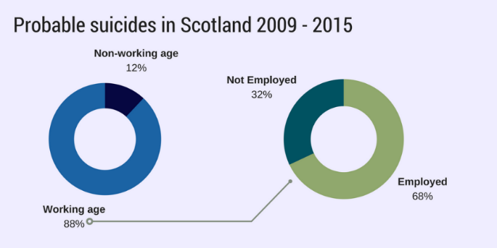 | retweet | retweet |  | LEAD | retweet
13.09 | Alcohol / drugs can exacerbate poor mental wellbeing and heighten the risk of a suicide attempt. But did you know that employers have a key role in supporting staff? Being alcohol and drug aware can make a difference: https://goo.gl/Eh2YTi #WSPD |  | retweet |  | LEAD
13.09 | Partnership highlighting for rural mental health and suicide prevention in D&G (social media video 1 – 2 minutes in length)  Text:  Partnership working to improve rural mental health and prevent suicide. #WSPD | retweet | LEAD
13.09 | Partnership highlighting for housing association and suicide prevention in Glasgow (social media video 1- 2 minutes in length)  Text:  Partnership working to increase knowledge and understanding of suicide and its prevention #WSPD | retweet | LEAD
13.09 | Partnership highlighting for film and suicide prevention in Glasgow (social media video 1- 2 minutes in length)  Text:  Partnership working to raise awareness and break the stigma around suicide #WSPD |  | LEAD
13.09 | Partnership working is key to preventing suicide - it's at the heart of our Locations of Concern guidance. Have you and other community planning partners accessed the guidance yet? https://goo.gl/MUAJcB #WSPD #SuicideIsPreventable | retweet | retweet |  |  |  |  | LEAD
14.09 | Irresponsible reporting of suicide can lead to an increase in suicidal behaviour – visit our page about @Samaritans and @NUJScotland’s guidelines to find out more. Preventing suicide is everyone’s business: https://goo.gl/jF3ec9 #WSPD  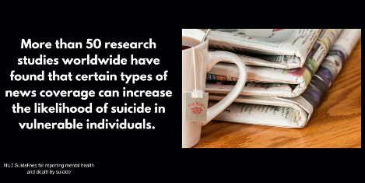 | retweet | LEAD
14.09 | Dispel the myths and gain an insight into how to talk to someone about #suicide. It could change a life. Access The Art of Conversation to find out more: https://goo.gl/tQwGQM #WSPD  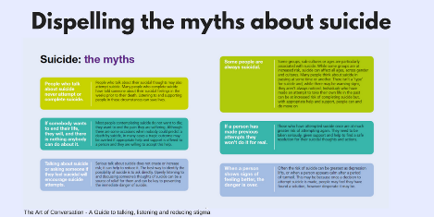 | retweet | LEAD | retweet | retweet
14.09 | Anyone can act on the warning sign of suicide they see in others. Asking a friend, relative, or colleague directly about their feelings can help to save their life. Read our guide about the art of conversation: https://goo.gl/tQwGQM #WSPD  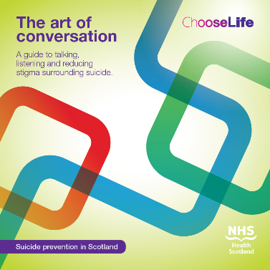 | retweet | Lead
14.09 | Talking and listening is the most potent tool to prevent #suicide. Anyone can have thoughts of suicide. Everyone can learn to help. Visit our website to find out more: https://goo.gl/2iTtFV #WSPD  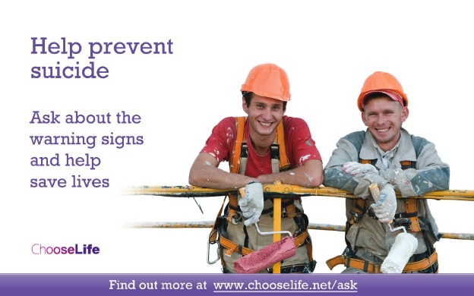 | retweet | retweet |  |  | Lead
14.09 | We have made progress over the last 16 years to reduce #suicides by 20%. @scotgov new action plan calls for a further reduction of 20% by 2022. This needs us all to play a role. #WSPD #TogetherWeCanPreventSuicides  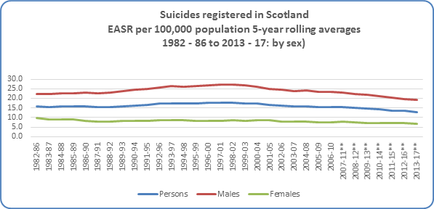 | retweet | LEAD

